Email Usage
To access your email, you must first change the hard password provided to you.
Password change link
After changing your password, your email access will be activated. You can use your email from the link below.
Webmail

Outlook Setup
1. Open the new Outlook application.
2. On the screen that opens, check your corporate email address that appears as the suggested account. (e.g., username@ihu.edu.tr)
3. Click the Continue button.
Result: Outlook will start the process of adding the corporate account.
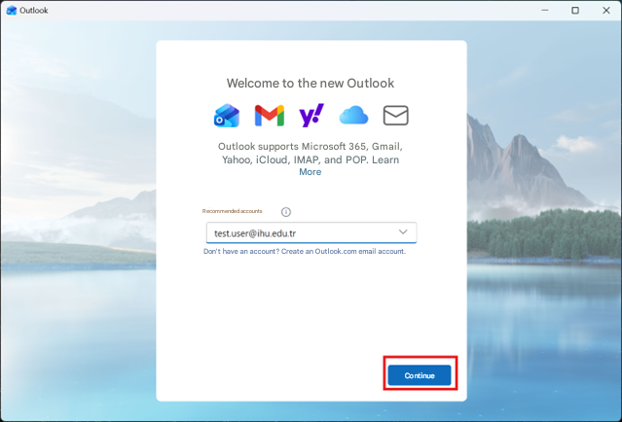

1. On the screen that opens, click the Continue button.
2. Wait for the account synchronization and permission processes to complete. Result: Email, calendar, and contacts will be synchronized with Outlook. Note: If Cancel is selected at this step, the account adding process will not be completed.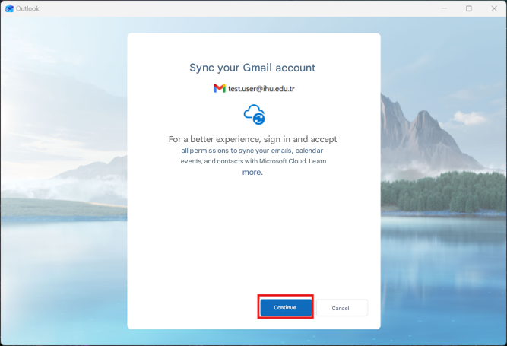
1. On the screen that opens, enter your institutional email address (e.g., username@ihu.edu.tr).
2. Click the Next button.
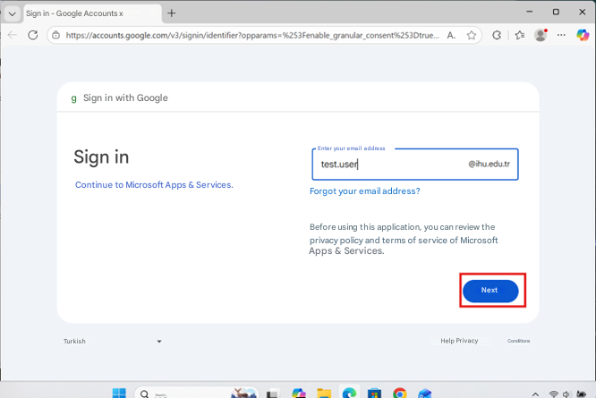

1. Enter your Google account password.
2. Click the Next button.
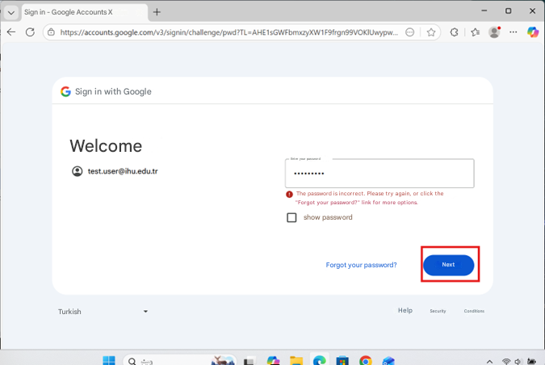
10. On the authorization screen that opens, click the Continue button.
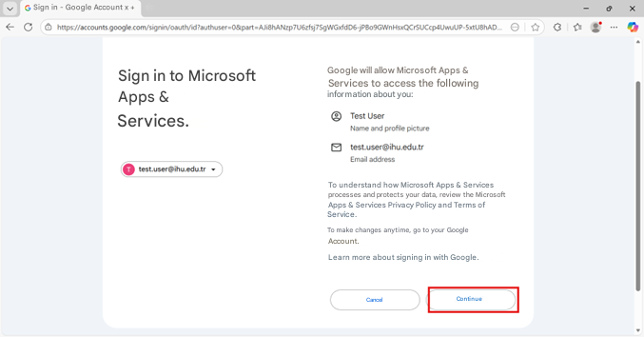
10. Make sure the "Select All" option is checked.
11. Click the "Continue" button at the bottom of the page.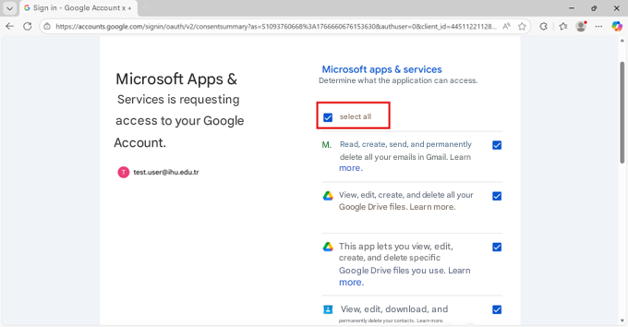
13. In the warning window that opens, click the Open button.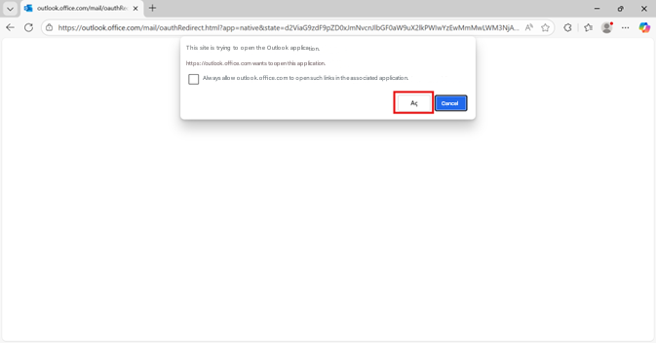
● The Outlook application opens.
● The Inbox is displayed.
● Emails begin syncing.
Result: Outlook setup is successfully completed.
