How to Install Stata v.15 on Mac OS X

To use Stata v.15, you must be connected to our university's network.

1 - From the Finder menu, click Go>Connect to Server and type 192.168.0.215 as the IP address.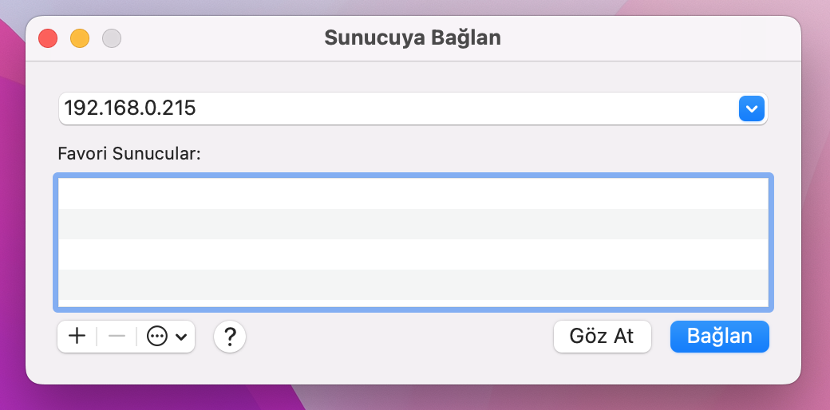

2 – Click Connect.
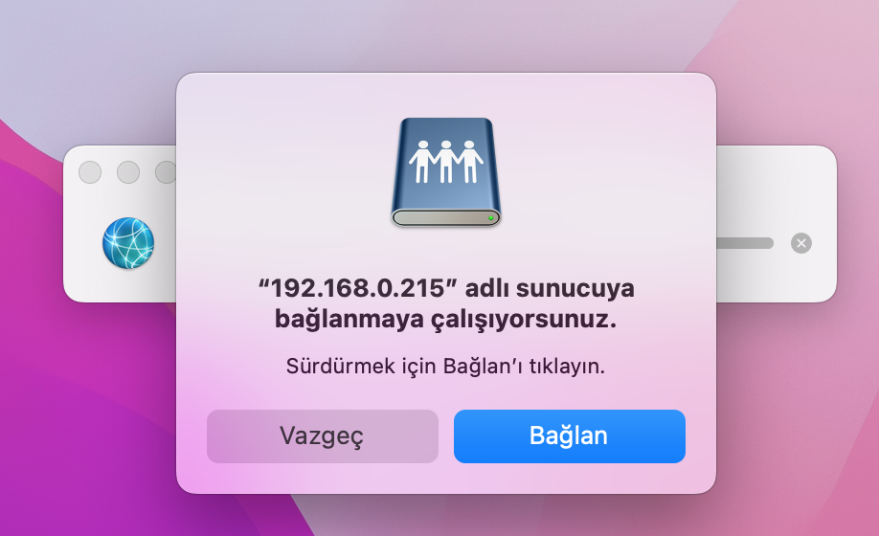

3- The server will ask you which user account information you want to use to connect. You can enter your own username and password on this screen. "Keep this password in my keychain" must be selected.
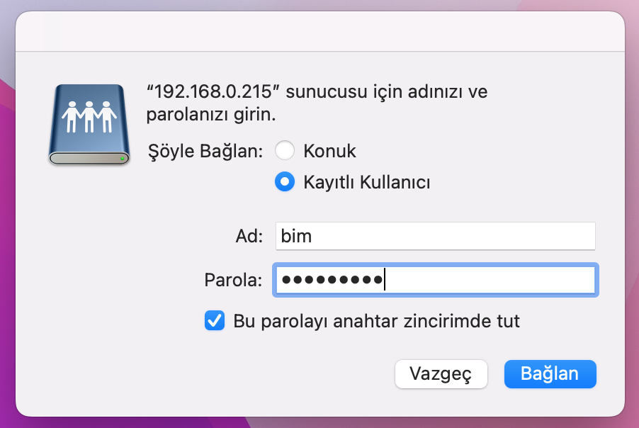

4 – With Stata-Macos selected, click OK.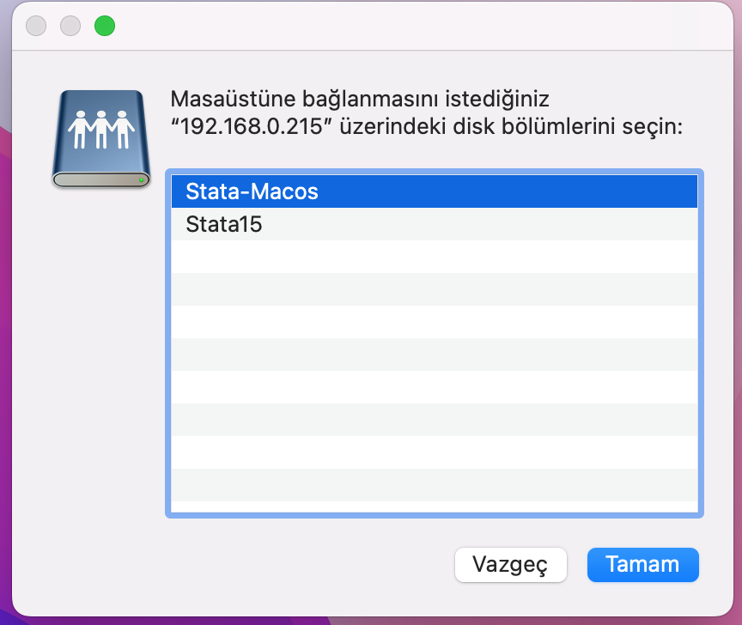
5 – Right-click on the “StataIC” program in the opened folder and select “Make Search”.
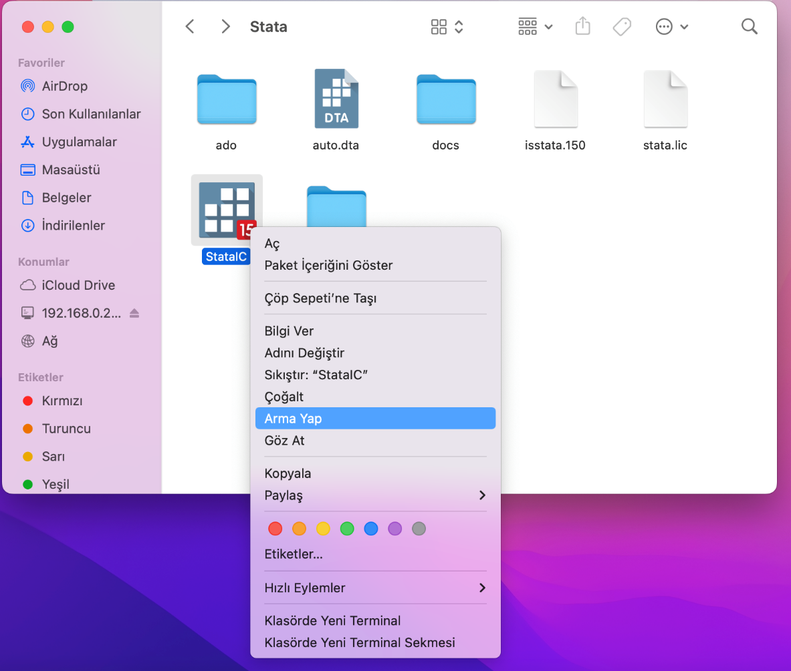

- The StataIC program must be added as a shortcut to your desktop. You can run the program from this shortcut as long as you are connected to the IHU or IHU-OGRENCI Wi-Fi network.

If you experience any problems, you can request support via the IT/Technical Support section at destek.ihu.edu.tr.

Department of Information Technology Services.

