MAXQDA Installation Instructions for macOS

To use the MAXQDA program, your computer must be connected to the IHU network.
Supported Versions: macOS 15.x (Sequoia), 14.x (Sonoma), 13.x (Ventura), 12.x (Monterey), 11.x (Big Sur), 10.15 (Catalina), 10.14 (Mojave)

- Download the MAXQDA (macOS) installation file from the following link:
👉https://www.maxqda.com/updates/24/MAXQDA24.dmg


2. Click the "MAXQDA24" button to start the installation.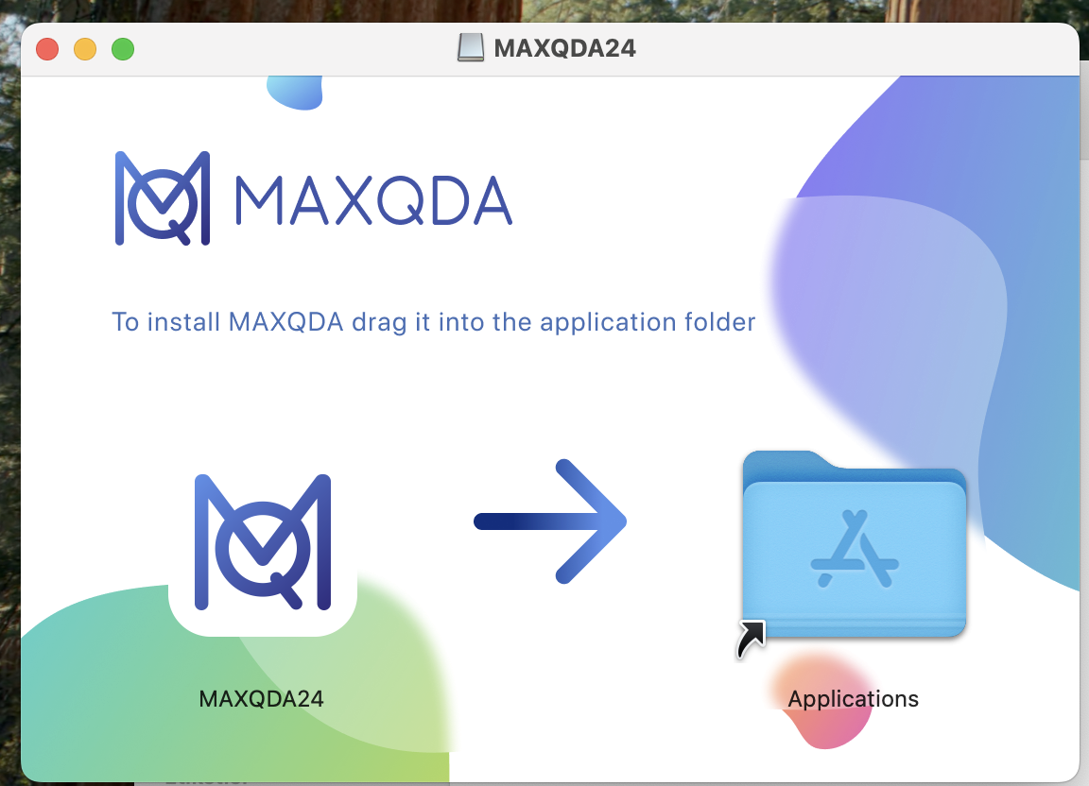
3. On the opened screen, accept the license agreement to proceed.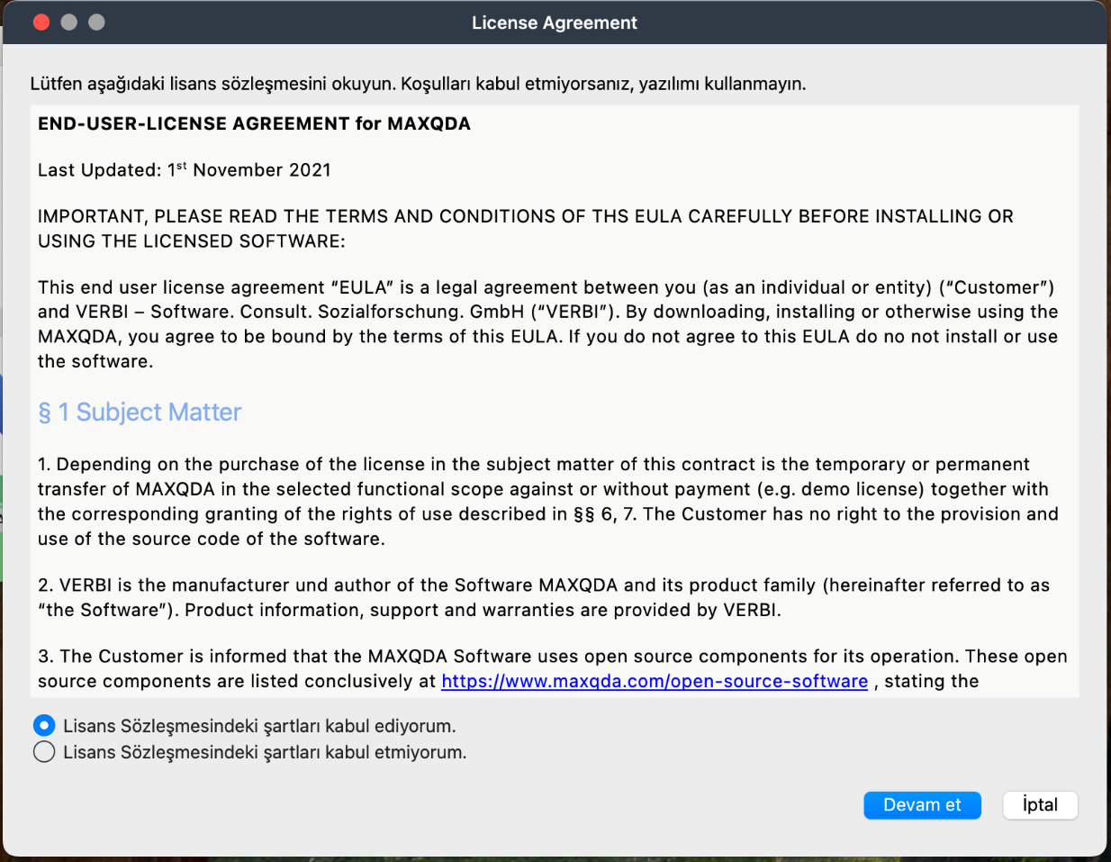

4. Then, click the "Continue" button to accept the privacy policy.
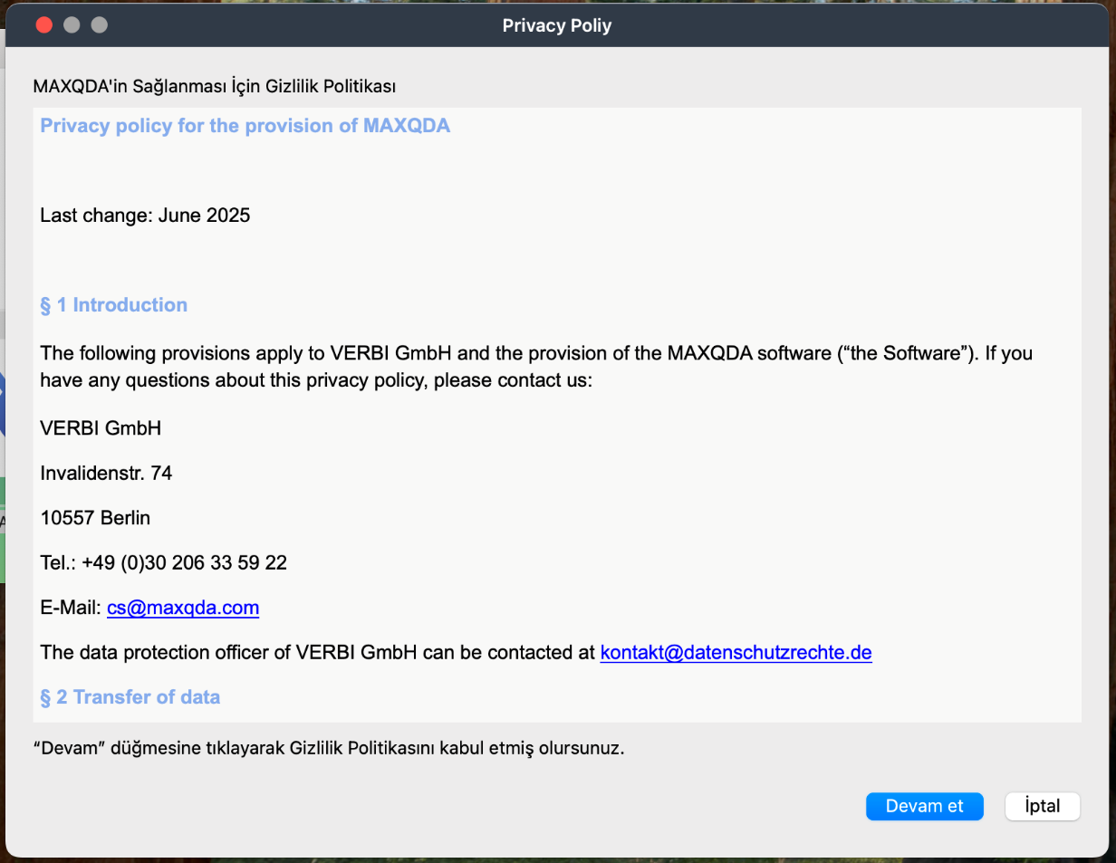
5. On the next screen, select the "Connect to your institution's network license" option.

6. On the next screen, select the "Allow MAXQDA24 to discover devices on local networks?" option and click "Allow."


7. Enter the following information:
- Server Address : 192.168.0.217
- Connection Port : 21990
While the “Search for licenses automatically” option is checked, click the "Refresh" button.
When the license name appears, select:
MAXQDA_Academia_Annual_Subscription_Network_License_10_users
Then click the "Connect" button.
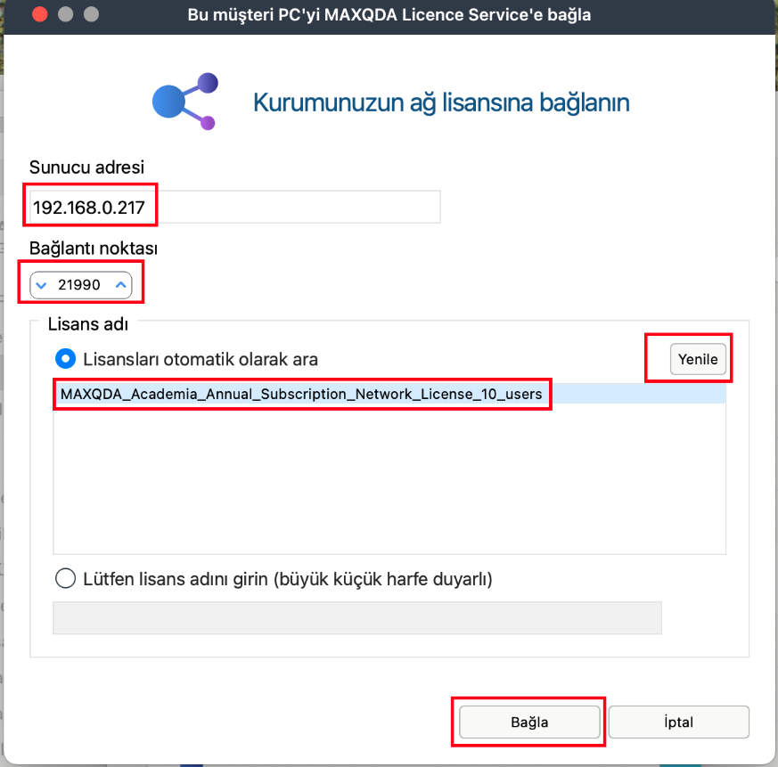
8. The program will connect to the license server and automatically retrieve the necessary license information.
- To run the program, click on the MAXQDA24.dmg file.
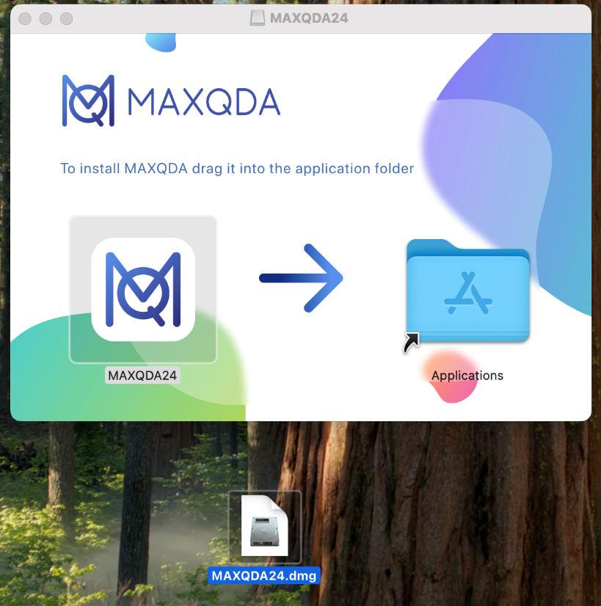
9. The program will check the license information by connecting to the license server.
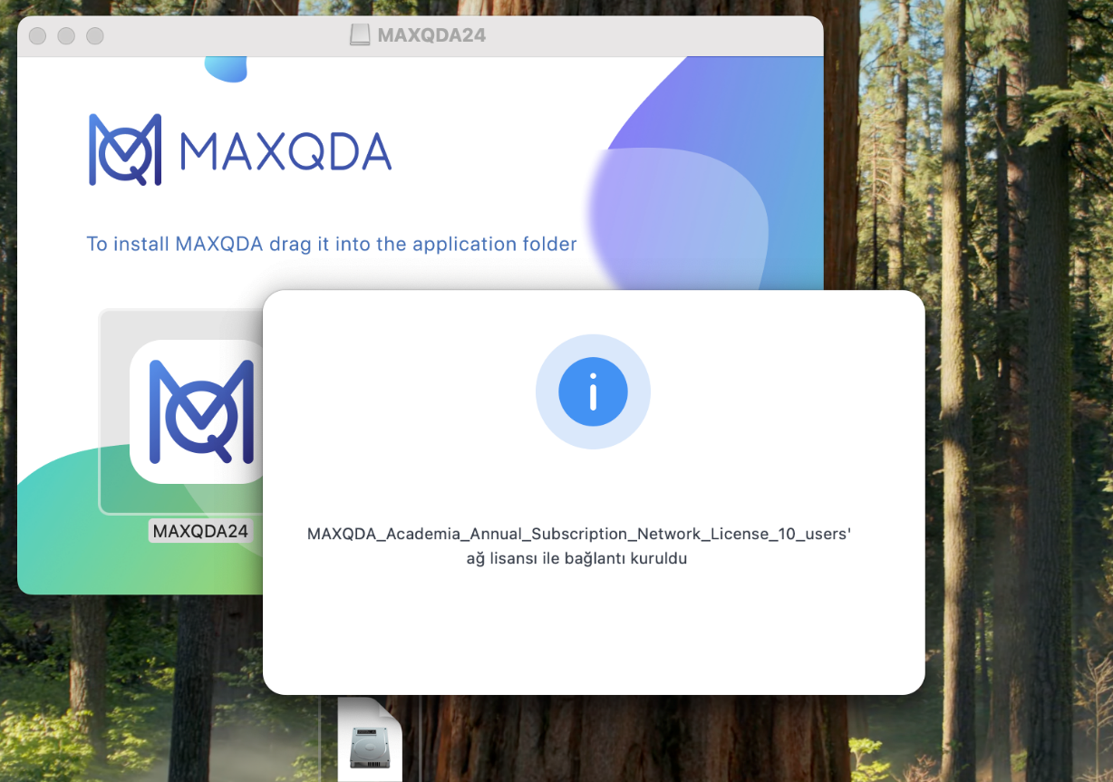
10. After connecting to the license server, the required license information will be automatically retrieved. Then, MAXQDA will open automatically.


Ibn Haldun University, Department Of Information Services

