MAXQDA Installation Instructions for Windows

To use the MAXQDA program, your computer must be connected to the IHU network.
Supported Versions: Windows 11, 10 (64-bit)

1. Download the MAXQDA (Windows) installation file from the following link:
👉 https://www.maxqda.com/updates/24/MAXQDA24_Setup.msi

2. Run the installation file.
On the “Welcome to MAXQDA 24” screen, click “Next” to proceed

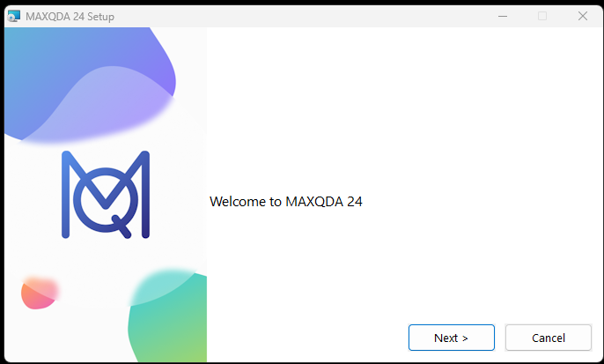
3. Click “Install” to start the installation.
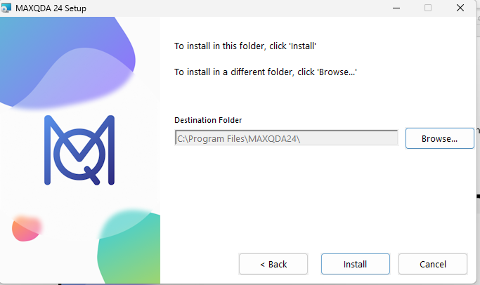
4. When the installation is complete, click “Finish” to finalize the process. The program will open automatically.
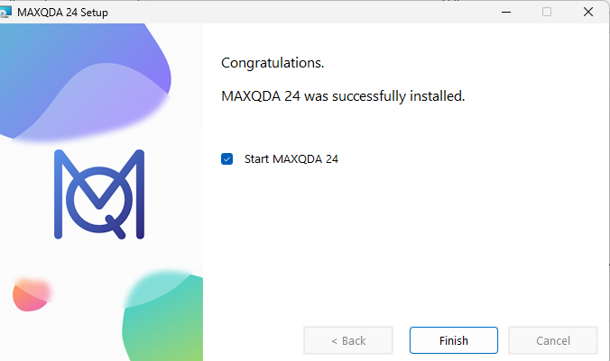

5. On the opened screen, accept the license agreement to proceed.
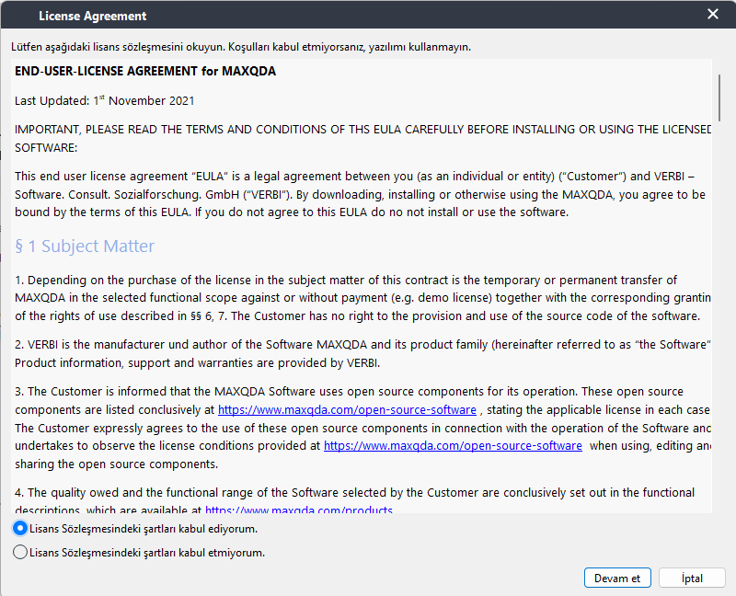
6. Then, click the "Continue" button to accept the privacy policy.
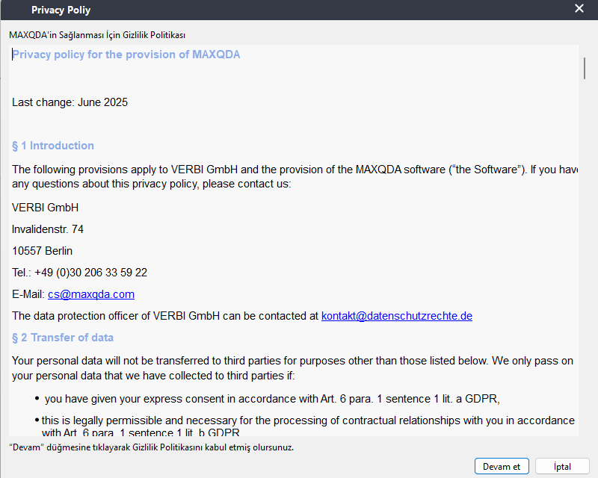
7. On the next screen, select the "Connect to your institution's network license" option.
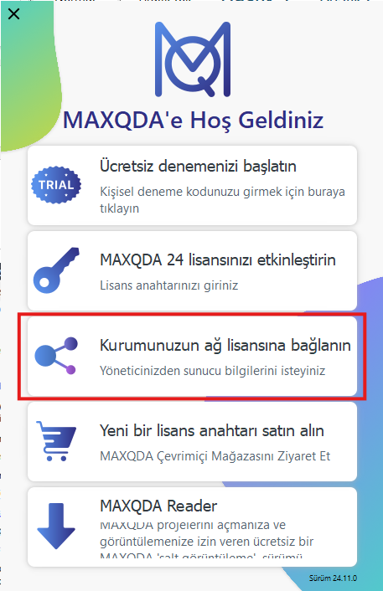

8. Enter the following information:
- Server Address: 192.168.0.217
- Connection Port: 21990
While the “Search for licenses automatically” option is checked, click the "Refresh" button.
When the license name appears, select:
MAXQDA_Academia_Annual_Subscription_Network_License_10_users
Then click the "Connect" button.
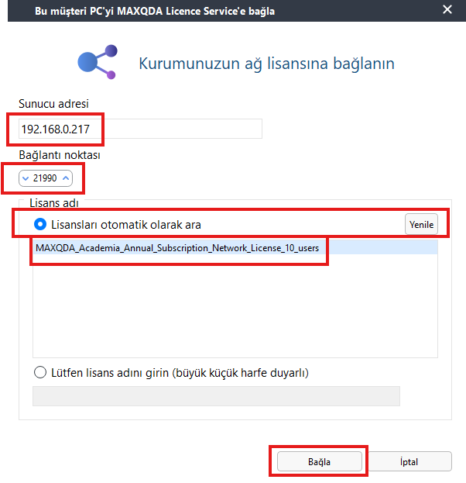
9. The program will connect to the license server and automatically retrieve the necessary license information. After that, MAXQDA will open automatically.


Ibn Haldun University, Department of Information Services

