How to Install Stata v.15 on Windows Operating Systems
How to Install Stata v.15

To use the Stata v.15 program, you must be connected to our university's network.

1 - Right-click on My Computer => Connect to Network Drive
1 - Right-click on My Computer => Connect to Network Drive.
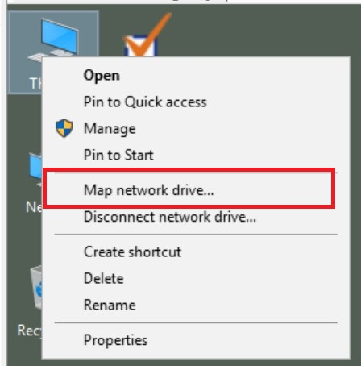

2 - Type \\192.168.0.215\Stata15 in the folder section.

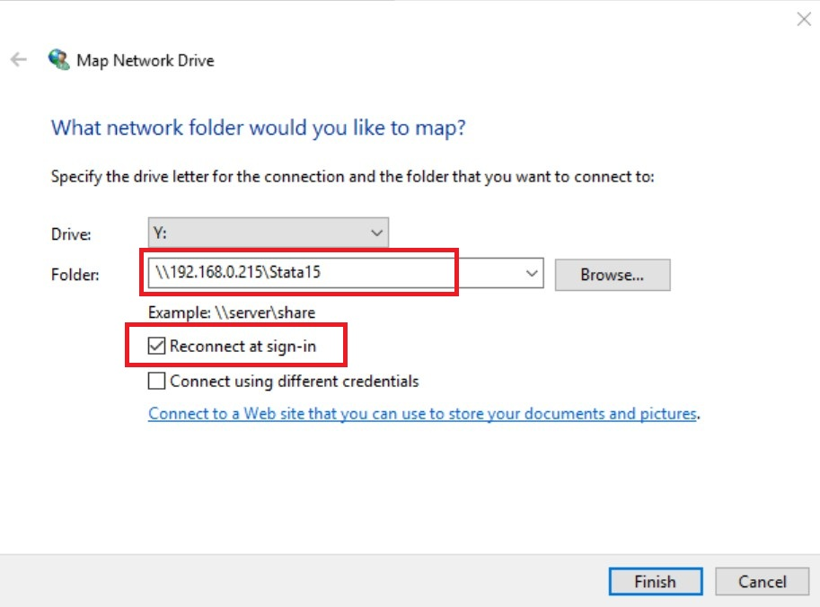

3 - After connecting to the network drive, the page will open automatically. If it does not open, click on the Stata15 network drive at the bottom of the computer to access the directory where the programs are located.
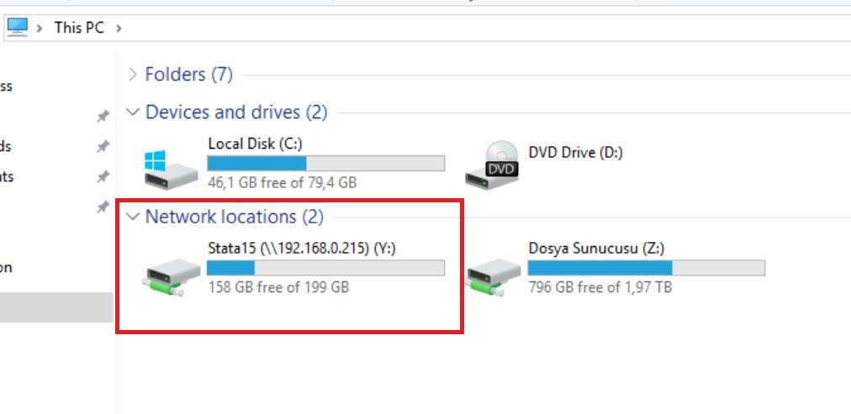

4 - On the opened page, right-click on stata-64.exe => Send => Desktop (Create Shortcut)
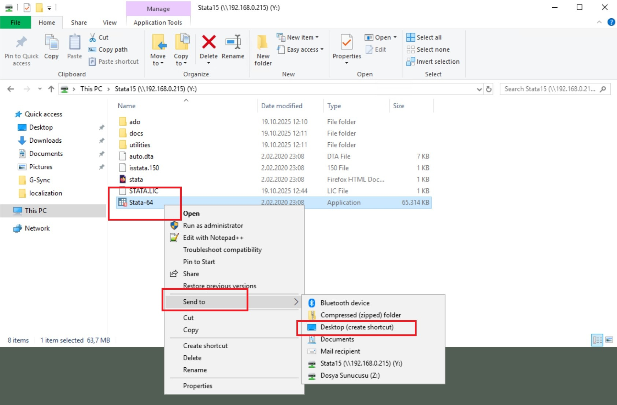
5 - Right-click on the Stata-64.exe shortcut on the desktop => Properties
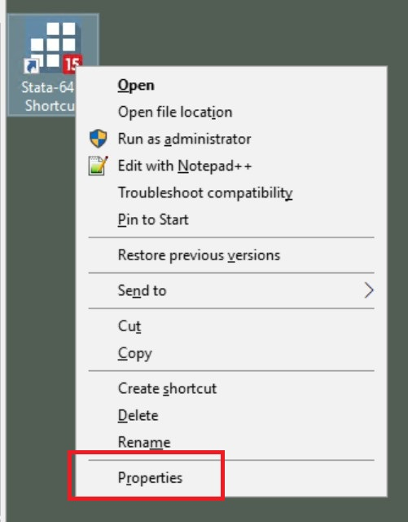
6 - In the Shortcut tab, enter %HOMEDRIVE%%HOMEPATH% in the Start in field.
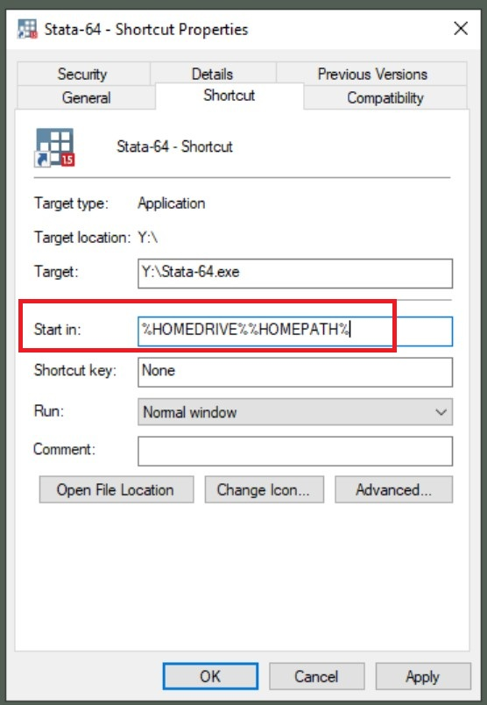
8 - Then, when you click on the program's shortcut on the desktop and select Run, the program will start.
